A helpful guide to Transitions
for young people and their parents and carers.

All artwork in this booklet is produced by those with a lived experience of mental health.
All artwork in this booklet is produced by those with a lived experience of mental health.

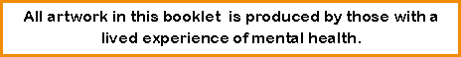

The aim of this Booklet is to support you with your transition and prepare you to take your next step with confidence!

Please work through this booklet with your CAMHS clinician, and where possible, your parent or carer during your transition.
It will provide information on what to expect during your transition, links to websites and support that you may find helpful during and after your transition and activities, that you can complete with your CAMHS clinician, to help you to develop self-help and self-care tools.
There is also a page for parents, please share this with them as they are going through the transition with you and will need their own support with the changes.
What is Transition?
Transition is the process of leaving CAMHS because you are turning 18.
When does it happen?
The process will often begin when you are 17 and 6 months old.

What happens next?

There are a variety of outcomes during the transition process and together with CAMHS you will create a Transitions Care Plan and work towards the one best suited to your needs.
This book prepares you for each outcome, so pick the one most relevant for you.
It is important to speak to your clinician about other changes such as moving out or moving away to study as these may have an impact on the outcome of your transition.
Where do I go if I need help once I have left CAMHS?
This will depend on the outcome of your transition, this may be a family member or friend, your GP or your new Adult services team.
For emergency help call 999 or visit A&E.
Please also see the back page of this booklet for online and local information and support.
Where can I leave feedback ?
You can fill in our transitions surveys on our CAMHS webpage at www.hpftcamhs.nhs.uk

What Next?
Being Discharged to GP
You may come to the decision with your clinician that being discharged back to the GP is the best option. In this situation if you require any continued medication the GP will continue to prescribe this for you.
You may also find it helpful to use the tools you have developed with your CAMHS clinician to look after your own mental health and wellbeing.
Finally you may benefit from some local support or online resources.
Visit the back page of this booklet and our CAMHS webpage at www.hpftcamhs.nhs.uk for helpful contacts.

Being Discharged from CAMHS
You may come to the decision with your clinician that being discharged from CAMHS is the best option.
You may no longer need support from services and may be able to take the tools you have developed with your CAMHS clinician and use them to take care of your own mental health and wellbeing. You may sometimes benefit from some local or online support.
Visit the back page of this booklet and our CAMHS webpage at www.hpftcamhs.nhs.uk for helpful contacts.
Referral to adult services
You may come to the decision with your clinician that it is best you are referred to Adult Mental Health Services (AMHS).

A transition planning meeting will be arranged with the AMHS. At this meeting the AMHS may identify alternative resources and it may be agreed you do not require a Specialist Adult Mental Health Service.
If everyone agrees the right step for you is to transfer to the AMHS, a transition meeting will be held to confirm your transfer and care plan. In this you will decide what your goals are. This booklet can help with that.
Please make use of the tools you have developed in this booklet and the helpful support contacts given on the back page or online during your transition.
When you turn 18 you will become responsible for your own healthcare and your parents/carers will need your consent to receive your personal and healthcare information.
They are often a form of support outside services so think carefully about this decision. We advise that you keep them involved, so they can continue to support you. You can share as little or as much as you like with them.
In order for us to continue to care for you, we may need to share some of your information with other services, in order to keep you safe. This will be discussed with you before it happens.
If you are unsure about anything please speak to your CAMHS clinician for advice.

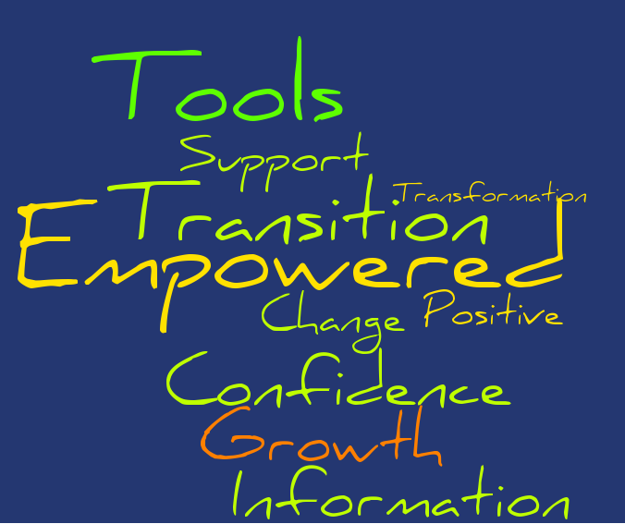

Information for Parents/Carers

In some cases you will have been very involved in your young person’s journey through Child and Adolescent Services (CAMHS) and therefore transition can be a big change for you too.
What will be different?
Once your young person turns 18 they will be responsible for their own healthcare decisions.
You will need their consent to be involved in and receive information about their healthcare.
We would encourage your continued involvement, however the decision will be there's. This means you won’t be able to attend appointments or access personal information about their care, without their consent.
If you have any questions or concerns about this please speak to a professional from CAMHS before your young person is discharged.

Please visit www.hpftcamhs.nhs.uk and fill in our parent/carer transitions surveys so we can continue to improve this process for other parents and carers.

During the transition process it may be helpful for you to talk to and meet with other parents and carers who are going through similar experiences.

Carers in Herts offers a variety of local support groups, information and workshop programmes. You can find details of these on their website.
www.carersinherts.org.uk

Support for Parents/Carers

Helpful Tips
Where possible we recommend that you work through this booklet with your young person.
It would be helpful for you to know what helps them, so you can support them at home. There is a section in this booklet that encourages the young person to write down what they want to share with you, ask them about what they put in there as a conversation starter.
Your own mental health and wellbeing is important during this time and if you need it, seek support for yourself by calling 0300 777 0707.

Your Transitions Care Plan Summary

Aims/Goals/Objectives

…………………………………………..
…………………………………………..
…………………………………………..
…………………………………………..
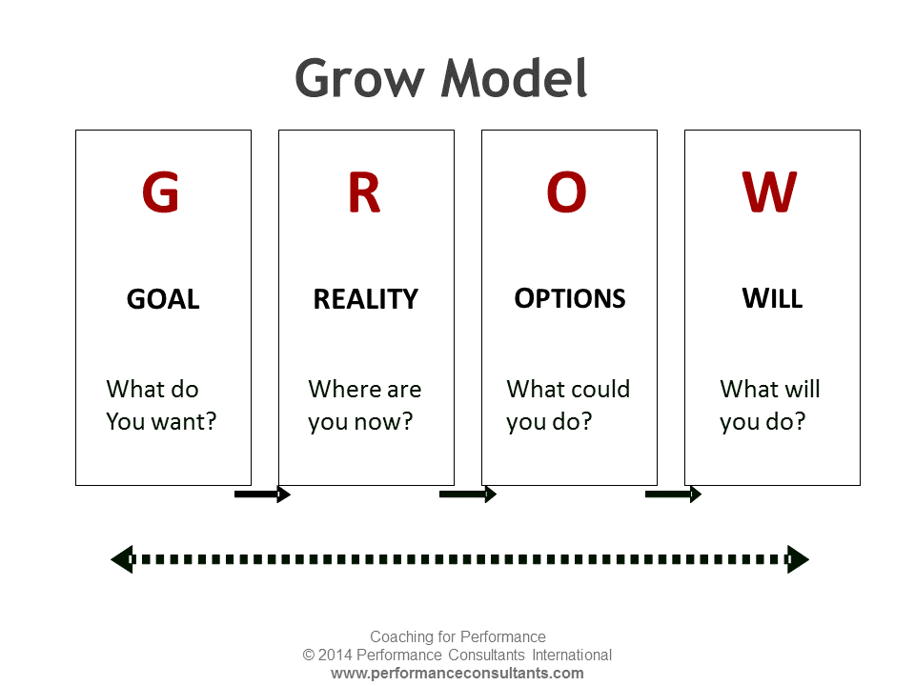You can use the GROW model to help you with this.

You should be involved in deciding what your goals are and making sure they are helpful.

Try to be realistic, you may not achieve all these goals before you leave CAMHS, and that is ok.

Please visit www.hpftcamhs.nhs.uk to fill in our pre - transition survey and tell us about your transition experience.

You may want to think about what support you will need once you have left CAMHS.
Think about the practical support you may need such as getting to appointments or the emotional support you may need such as who you can talk to or what self-help tools would be useful.

What do I need support with? (exam anxiety) | Who is the best person to support me with this? (Me) | How can I get this support? (Use tools)
For Emergency support call 999 or visit A&E.

It is important to celebrate all that you have achieved with CAMHS. Big or small, write or draw everything you’re proud of.

Getting to know me!

It can be frustrating to go over things multiple times when talking to people. Please use this space to write down what you want to share about yourself and with who. This will help them be able to understand and support you better.
Share
With
Parents/Carers...

Share
With
Friends….

Share
With
A professional….

Doodle Page
If you are feeling overwhelmed, please use this space to help you to calm down and clear your thoughts.

What Helps Me?
As you work through and try different techniques make a note here, of the ones that work for you.

Problem Solving Steps

What is the problem?

How can I overcome this?

Who might be able to help me?

If I can’t solve the problem, how can I feel better about it?

Reviewing your goals
We recommend you review your goals six months after your transition. If you have transferred to an Adult Team please do this with your named contact or care coordinator.

Aims/Goals/Objectives

…………………………………………..
…………………………………………..
…………………………………………..
You can use the GROW model to help you.

Important Details and Contact Information.

In order for us to continue to care for you, we may need to share some of your information with other organisations to keep you safe.

Please visit www.hpftcamhs.nhs.uk and fill out our post transition survey so we can continue to improve this process for other young people.

Helpful Apps and Services

Hub of Hope
Visit www.hubofhope.co.uk and put in your postcode or postcodes nearby to find local support.

Kooth
Free online counselling service available at www.kooth.com

Young Minds
Useful and young person friendly information available at www.youngminds.org.uk

Mind in Mid Herts
Local support and information available at www.mindinmidherts.org.uk

The Samaritans
Email jo@samaritans.org or call 116 123 free of charge 24/7 for support and advice.

Headspace
A simple meditation app with a free trial to help you feel calmer.

Headmeds
Young person friendly information on medication available at www.headmeds.org.uk

Youth Connexions
For a variety of practical information and advice and support visit www.ychertfordshire.org

Get Self Help
Visit getselfhelp.co.uk to download free worksheets which may help you.

